## **Experiment Name:** Process handling in Linux.

## **Experiment No:** 03

**Objective:** To learn the mechanisms of OS to handle processes and threads and their communication and to To learn the mechanisms involved in memory management in contemporary OS

**“ls” command :**   
  
 Used to list folder contents.  You can view many kinds of file and folder attributes.

1. **ls** By itself, ls will simply list all your files in the current folder.  From fact #4, this literally does **ls .**
2. **ls -l** Provides a longer listing format including owners, permissions, size, and date modified.
3. **ls -a** Displays hidden files and folders as well as the normal listing.
4. **ls -al** Combine options to display both hidden files and in the long format.

**Screenshot:**

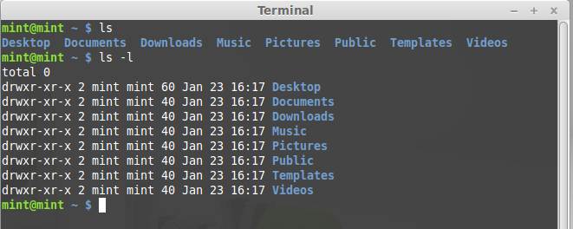

**Screenshot:**

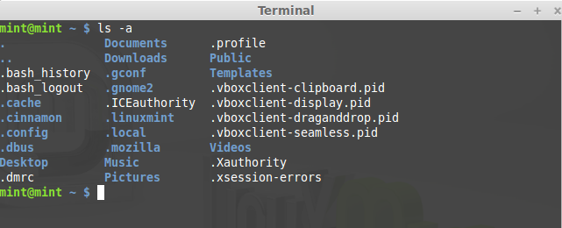

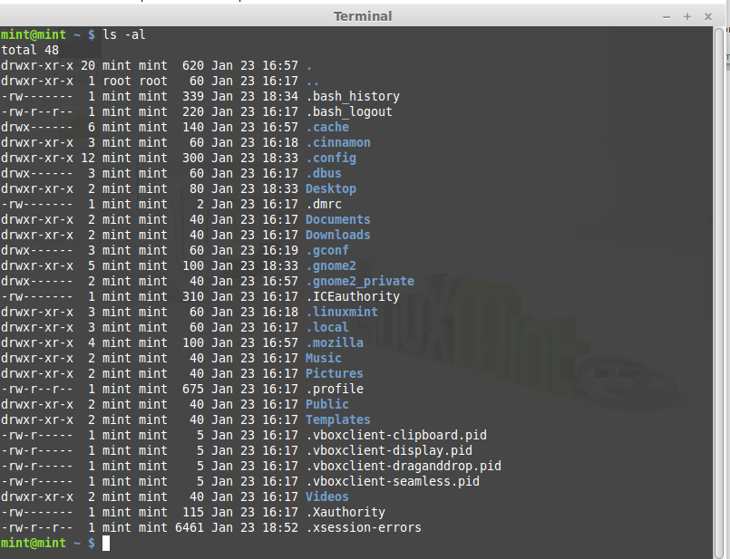

**“Ps” command:**

List processes:

**ps aux** List all processes in detail running on the system, including user, Process ID (PID), and name of process.  Using this, one can view their process list and if necessary, kill unnecessary or stalled processes.

**Screenshot:**

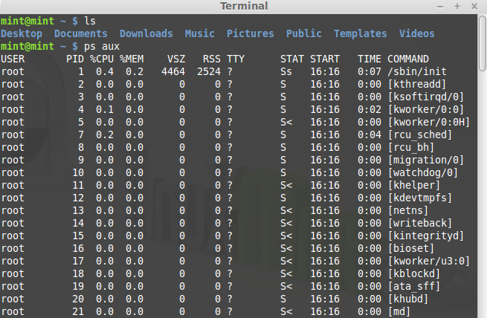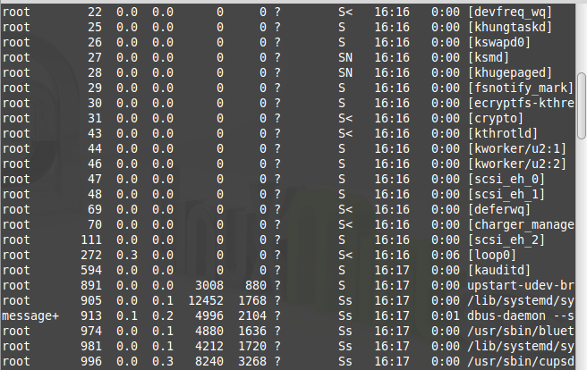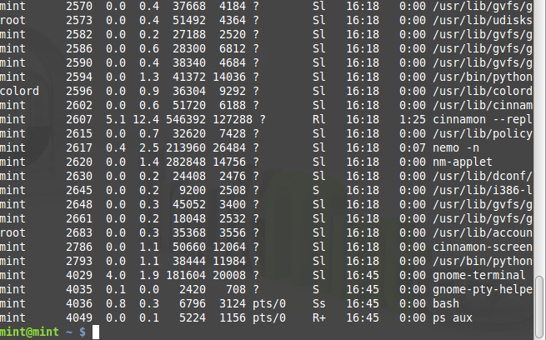

**killall program**  Killall kills *by name* all instances of said program.  If there are for example 3 firefox sessions open, **killall firefox** will do just that; kill all firefox sessions.

**Screenshot :**

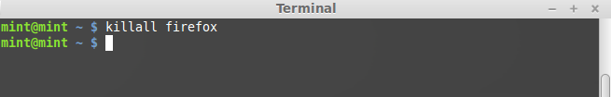

**Xkill** is a utility for forcing the X server to close connections to clients.

**Screenshot:**

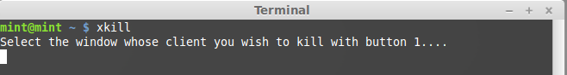

**Quick tips:**

Lost yourself in a directory?  Not sure where you are?  Type **pwd** to **p**rint **w**orking **d**irectory.

**Screenshot:**

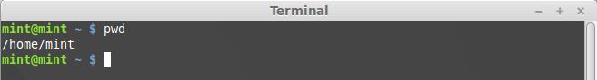

Want to calculate your disk space quickly?  **df -h** can give you a quick checkup.

**Screenshot :**

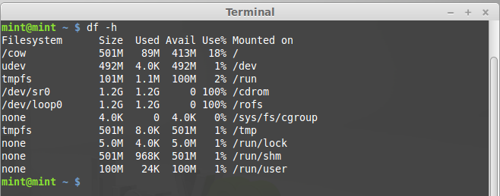

**du -cksh target_name** can do exactly that.  Want to calculate the size of the current folder?  **du -cksh** **.**

**Screenshot :**

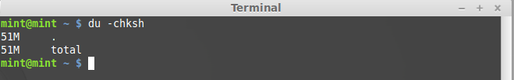

**Discussion :** After doing this lab we successfully learn about the implementation of process handling in linux and learn programmatically to implement simple OS mechanisms .